Freight Traffic in UK Ports — Personal Visualization Report

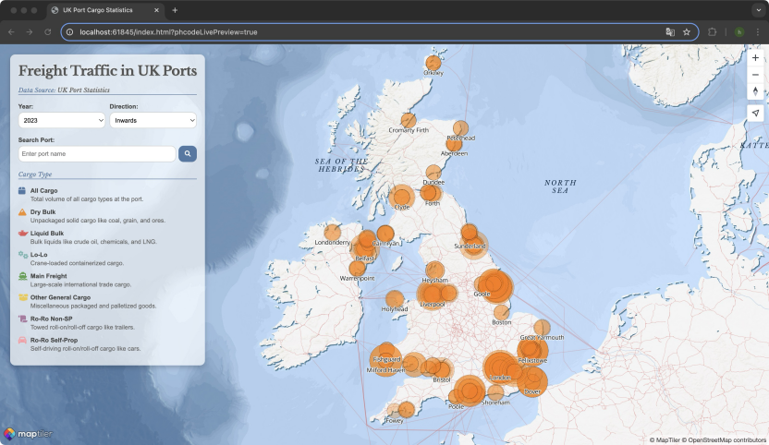

Figure 1: Webpage Homepage

**Introduction**

This visualization presents freight traffic at the top 30 UK ports, categorized by cargo type, trade direction (import/export), and year. The goal is to provide an interactive, user-friendly platform that enables users to explore freight distribution trends over time.

**Data Source & Processing**

The data comes from the UK government’s Port Freight Statistics,available at the following link: [UK Port Freight Statistics](https://www.gov.uk/government/statistical-data-sets/port-and-domestic-waterborne-freight-statistics-port#contents), integrating two datasets:

• PORT030 dataset – Contains tonnage data for different types of cargo handled at each port, categorized by import/export direction.

• Port and Domestic Waterborne Freight Table Information dataset – Provides the geographical coordinates of the ports.

These datasets were merged by port name, then grouped by year, direction, and cargo type, with total tonnage calculated. The processed dataset, processed_port_data.csv, is hosted on GitHub.

**Design**

1. Layer Design: The visualization is cantered on the UK region and is structured with three overlaid layers. Powered by MapTiler GL JS, the base layer features an ocean-style map, displaying key geographic elements such as seas, rivers, peninsulas, and islands. Above this, an additional tile layer illustrates waterways and land transport networks, while the topmost layer highlights the geographical distribution of the UK’s major ports.

2. User Interactions:

• Click a port → View cargo details.

• Double-click → Zoom into the port.

• Search function → Locate and zoom into a specific port.

• Dynamic filters → Adjust by year and trade direction.

3. Legend: Located below the control panel, the legend explains the colours used in the pie charts. Coloured circles on the map represent cargo volume handled by each port—larger and darker circles indicate higher tonnage. The visuals update dynamically when different years or import/export directions are selected.

**Technical Approach**

The visualization is built using HTML, CSS, and JavaScript, integrating multiple libraries to enhance functionality and user experience. D3.js is used for data processing and visualization, particularly for generating pie charts when a port is clicked. The pie charts provide a quick visual summary of cargo type distribution. Data is loaded from a GitHub-hosted CSV file.

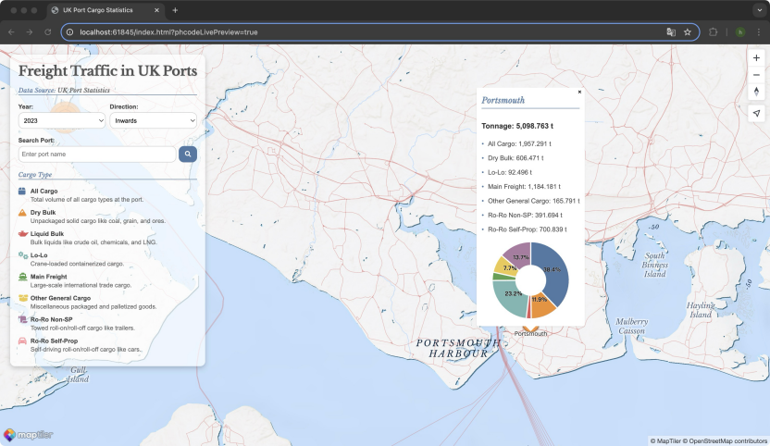

Figure 2: Viewing Tonnage by Cargo Type

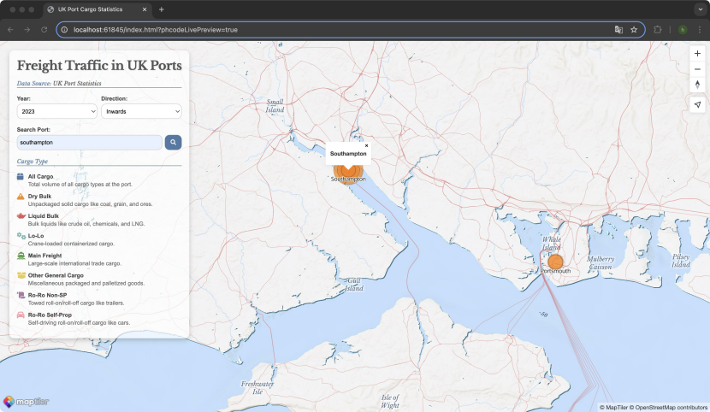

Figure 3: Searching for a Port

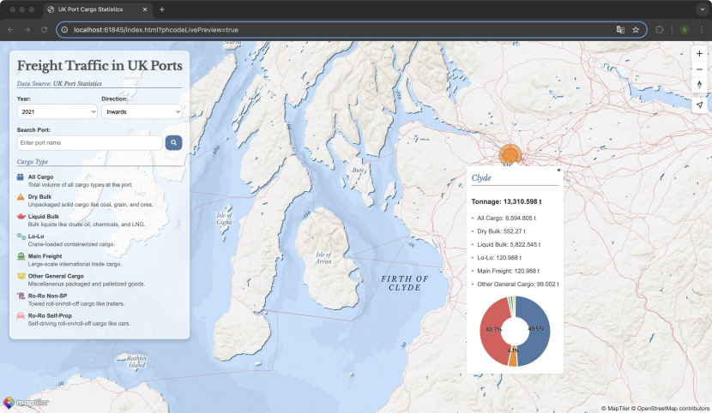

Figure 4: Displaying Waterbody and Island Names

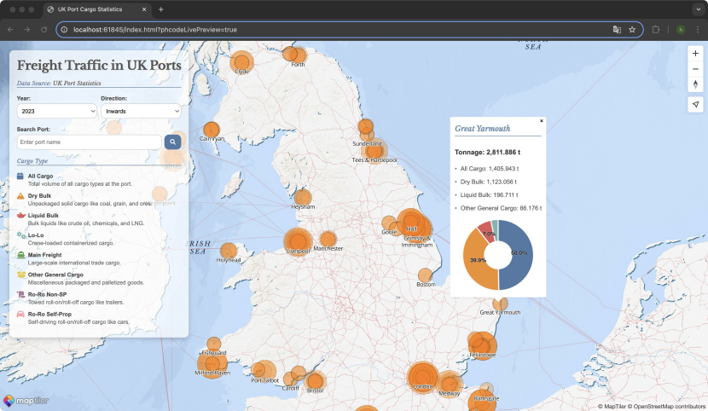

Figure 5: Auto-Zooming on a Double-Clicked Port

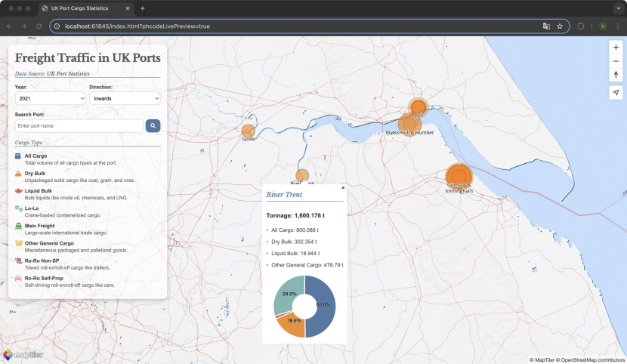

Figure 6: Visualizing Surrounding Waterway and Land Routes